**D15B/37 Mikil Lalwani Advance DevOps**

**Assignment 2**

**Aim-**

Create a REST API with the Serverless Framework.

**Procedure-**

1. Create a new lambda function.

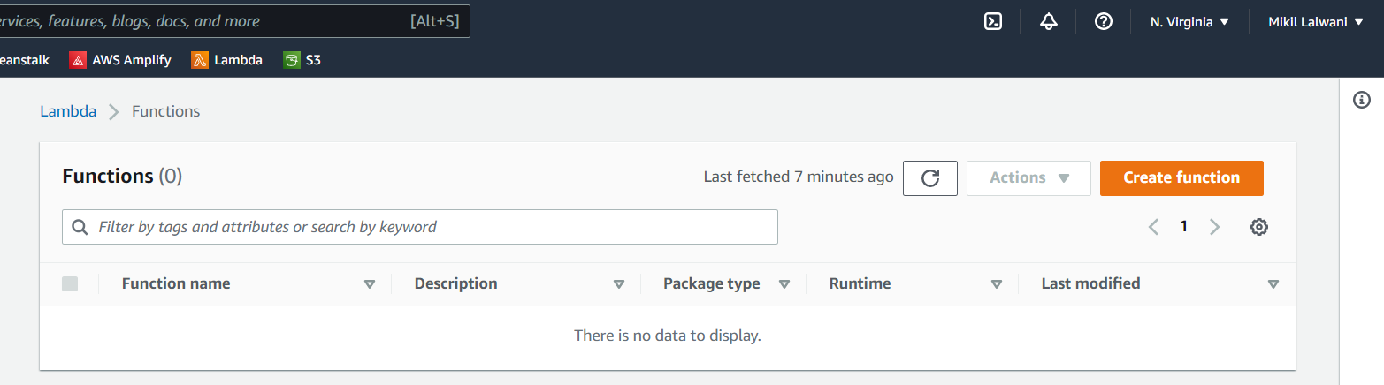

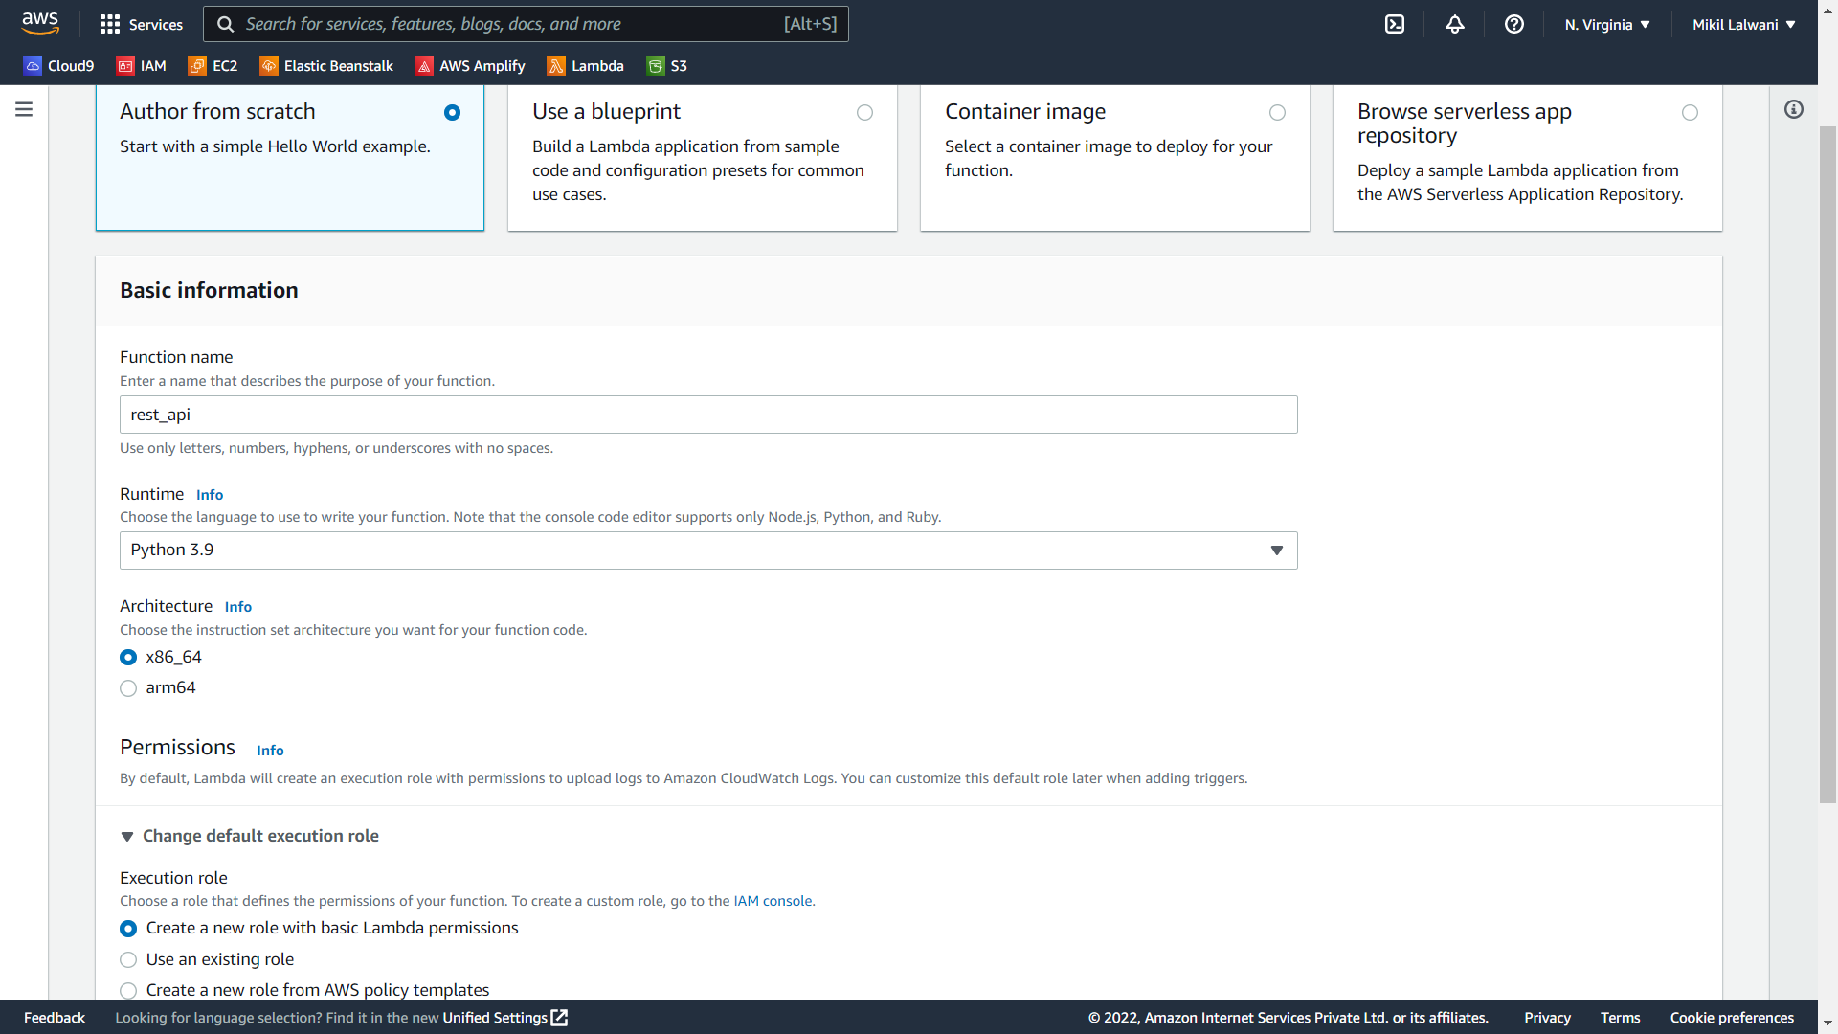

1. Write the code as needed and click on deploy.

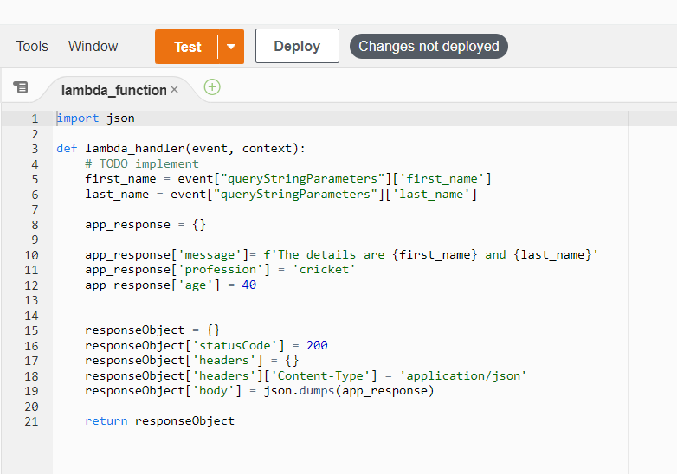

1. Goto API Gateway and create a new Rest API.

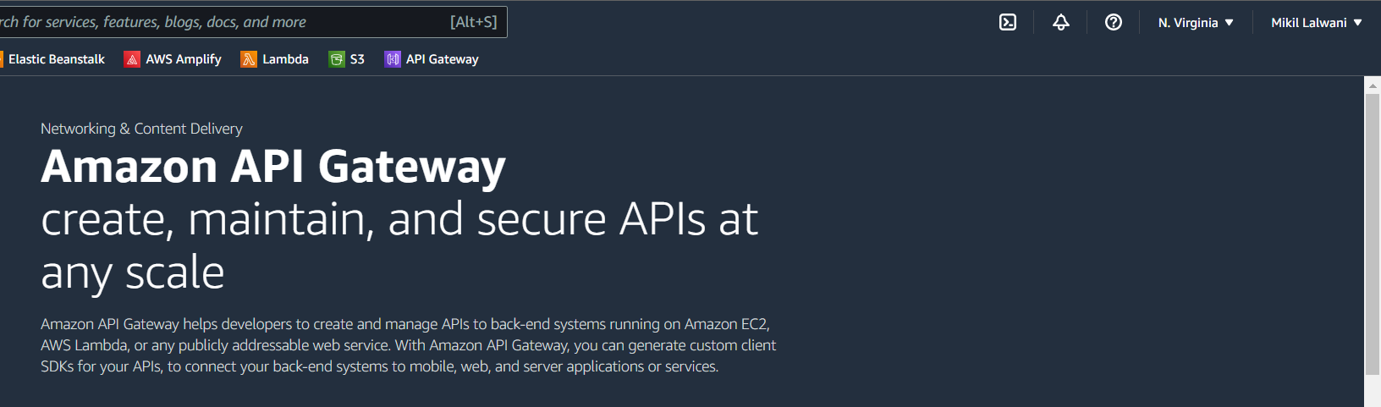

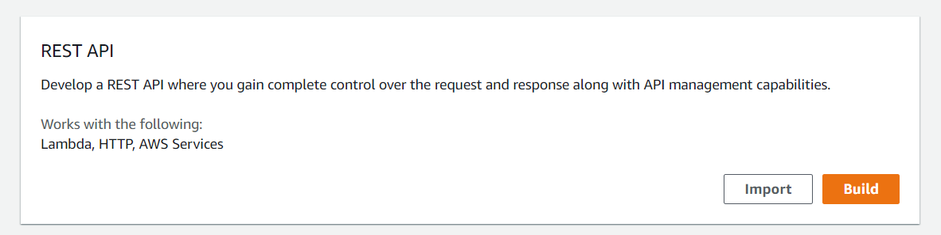

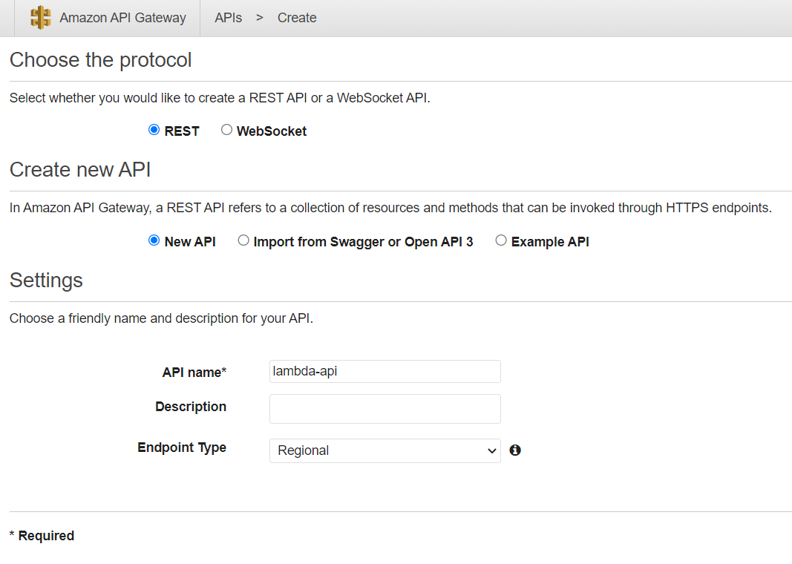

1. Select create the resource and create the resource.

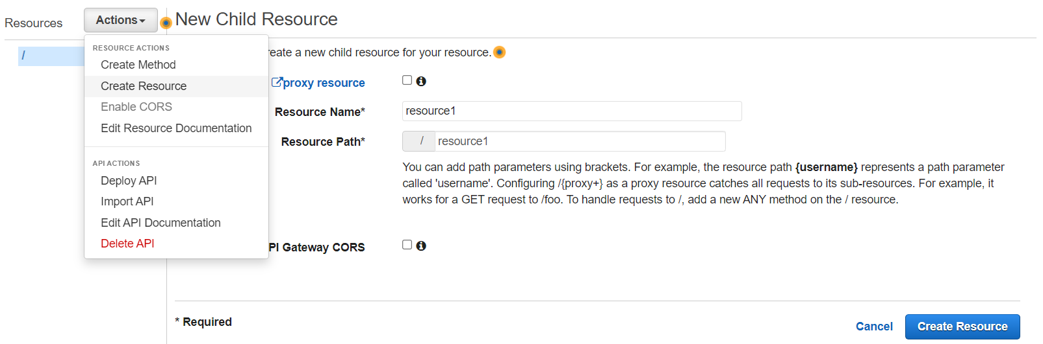

1. Create a Get method.

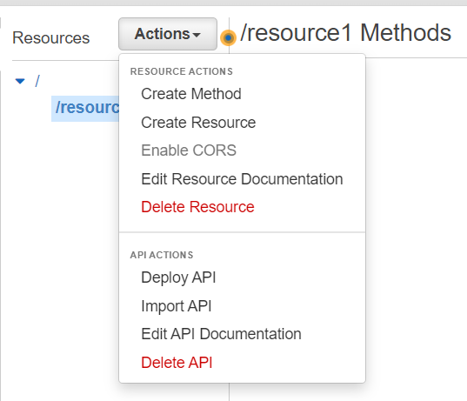

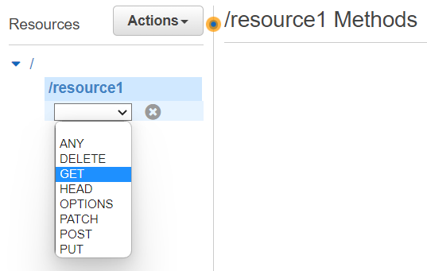

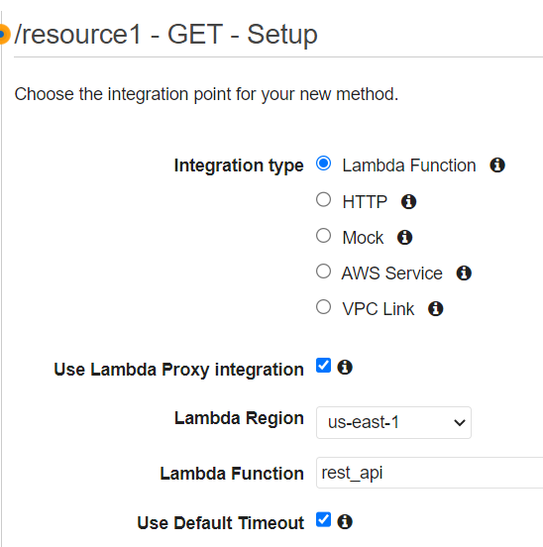

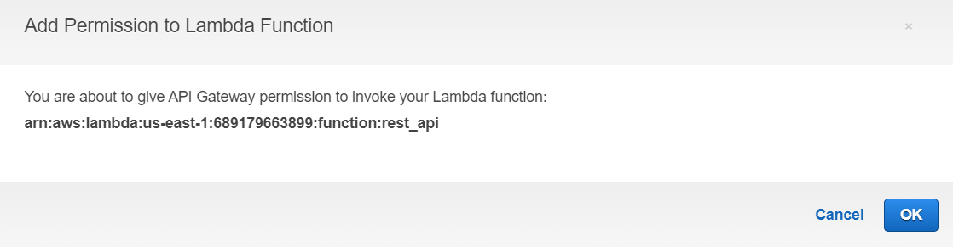

1. Deploy the API now.

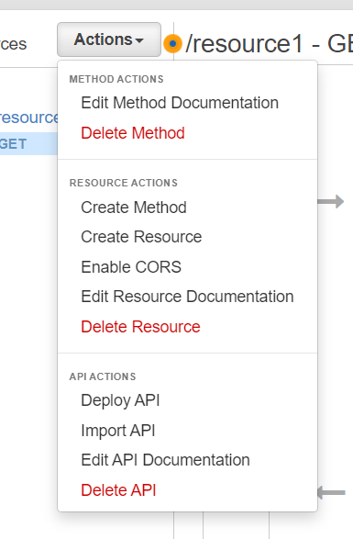

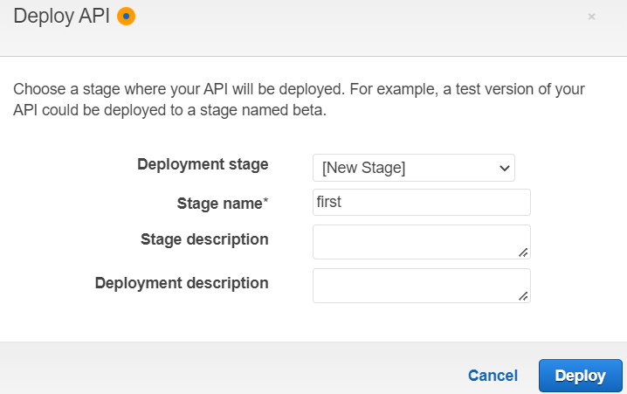

1. Now we can call the API.

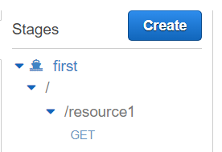

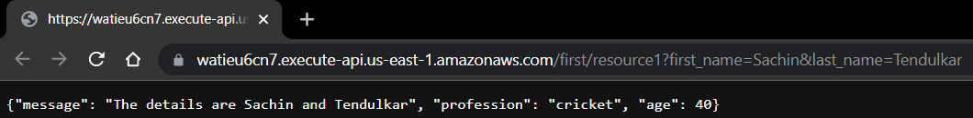

We have successfully created a REST API.